INF20005 Professional Capabilities for a Digital World: Team Charter

**1. Overview**

This document sets out the way your team should work together to complete **the Investigative Case Study.** Consider the charter as a living, breathing, dynamic and reflective document that should be reviewed and updated as your views and working arrangements evolve.

Make sure that each team member retains a copy of the charter. This charter should be lodged in your Canvas group home page.

Your team is expected to discuss the progress of the team against goals and task completion. At every stage of the investigative case study process a real world key professional skill will be highlighted that will help you effectively manage that process. As a group you will be required to reflect on your management of that process.

Through this process you will be better able to:

* Delegate roles and responsibilities.
* Plan and manage time.
* Share diverse perspectives.
* Refine understanding through discussion and explanation.
* Pool knowledge and skills.
* Hold one another (and be held) accountable.
* Develop new approaches to resolving differences.
* Establish a shared identity with other group members.

And these learnings will place you better to add value through teamwork once you enter the workforce.

**Team name:**

|  |
| --- |
|  |

**Team member names:**

*Please list the full name (first name and surname) of each team member*

|  |  |
| --- | --- |
|  |  |
|  |  |
|  |  |
|  |  |
|  |  |
|  |  |

# Investigative Case Study Objectives

Investigative case studies are designed to depict real world situations in which problems need to be solved. They reflect a problem-based teaching approach. These teaching methods are designed to develop collaborative reasoning and communication, problem solving and decision-making skills (Tunny, Papinczak & Young 2010; Bloomfield & Magney 2009). They are designed to allow students to learn by doing and specifically designed to replicate real world practice. In real world practice you will be expected to research issues that perhaps you would not previously have been exposed to. You will be expected to immerse yourself in the topic, getting to understand the challenges, opportunities and constraints in a relatively short time and then report back on your findings. Industry expects a problem-solving mindset. Some key skill-sets that underpin this mindset are:

* The ability to generate questions to guide your information research
* The ability to locate and manage information
* Using logical and rigorous inquiry strategies
* Providing support for your findings and conclusions (industry experts, industry best practice, academic research, bench marking etc.)
* The ability to motivate and persuade as to your findings

To enable these skill-sets, the following Unit Learning Objectives apply:

* Develop and present a resolved project outcome which synthesises understanding of ethical and socio-technical challenges faced by an ICT professional.
* Evaluate the role of standards, codes of conduct and legislative/regulatory obligations on the level of professionalism of the ICT industry.
* Communicate effectively as a professional and function as an effective leader or member of a diverse team.

# Team goals

|  |  |
| --- | --- |
|  |  |
| **Team goals** | **Measure of success** |
| **Example 1: Distinction for project**  **Example 2: Completion of all assessment tasks on time** | Example 1: Achieving a score of 75% + for Assessment Task Example 2: Clearly articulated milestones with roles and responsibilities and regular team meetings |
|  |  |
|  |  |
|  |  |
|  |  |
|  |  |
| Insert additional rows as required |  |

# Team SWOT

|  |  |  |  |
| --- | --- | --- | --- |
|  |  |  |  |
| **Team member** | **Strengths** | **Weaknesses** | **Ideal / preferred role / contribution** |
|  |  |  |  |
|  |  |  |  |
|  |  |  |  |
|  |  |  |  |
|  |  |  |  |
|  |  |  |  |
|  |  |  |  |

**Consider your own strengths, weaknesses and ideal or preferred roles in a team, and share these with your team members. You can use the Meyers Briggs (or any other freely available on the internet) Psychometric test to help you. Record them below. My advice is to get each team member to fill it in and then allocate case study tasks on that basis.**

# Team milestones

In this section work out the major milestones (e.g. research phase, writing, editing), who they are allocated to and their due dates.

|  |  |  |
| --- | --- | --- |
|  |  |  |
| **Task** | **Allocated to** | **Due date** |
|  |  |  |
|  |  |  |
|  |  |  |
|  |  |  |
|  |  |  |
|  |  |  |

***Note:*** *This is a significant clause in your charter, so make sure your team gives it lots of thought. You should avoid simply allocating big chunks of the assessments to each team member, it is preferable that all team members have a role in each aspect of each assessment task or at a minimum in the editing of each of the submissions.*

# Team meetings

The team will meet to discuss the progress of the project on the following dates:

|  |  |
| --- | --- |
|  |  |
| **Meeting** | **Date / time / how** |
|  |  |
|  |  |
|  |  |

# Agreed team behaviours

The team agrees to abide by the following guidelines for team conduct (this should include how conflicts will be resolved and expectations around timelines/milestones i.e. what happens if someone doesn’t deliver on time?): and expectations around timelines/milestones i.e. what happens if someone doesn’t deliver on time?):

|  |  |
| --- | --- |
|  |  |
| **Behaviour** | **Plan of action** |
| **Example: We agree to not be ‘free-riders’ in our own team** |  |
| **1** |  |
| **2** |  |
| **3** |  |
| **4** |  |
| **5** |  |
| **6** |  |
| **7** |  |
| **8** |  |

# Team member sign off

Sign off is required after the **initial** completion of the team charter.

|  |  |
| --- | --- |
|  |  |
| **Team member** | **Sign off**  **Tick the check box as evidence of sign off** |
|  | ☐ |
|  | ☐ |
|  | ☐ |
|  | ☐ |
|  | ☐ |

**Teams**

The investigative case study will be conducted in teams (groups). A team is a group of people who work with shared objectives within and across space, time and organisational boundaries and whom invariably use digital technologies to communicate and collaborate. In this unit, group work expectations can present students with challenges. It can be difficult to build relationships and trust within the given timeframes you have to form groups. There are tools and strategies you can use to overcome these challenges.

Understanding how teams form and the specific skills needed at each stage is important. For this purpose, we use Tuckman’s (1965; 1977) model of team formation to guide us. Knowing what needs to happen for groups and teams to perform is going to help you ensure that the teams you work in are more productive, quicker. The saying that a team is only as strong as its weakest link is very true.

# Tuckman’s Team Development Stages

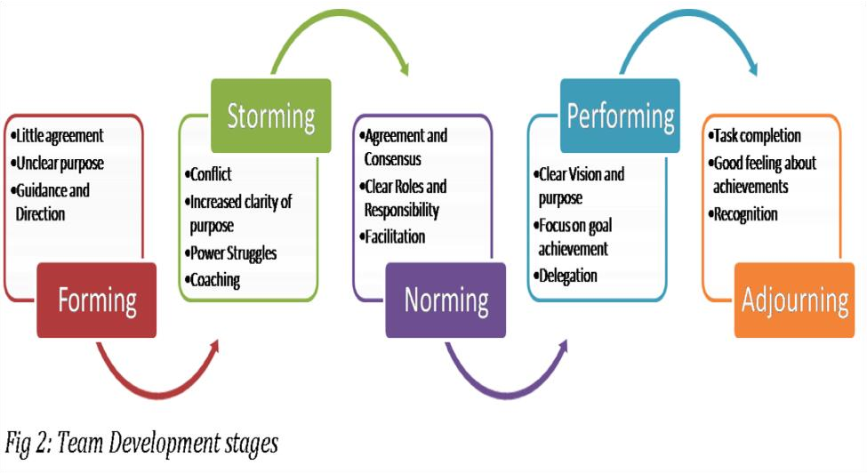

Tuckman, B. W 1965, Development Sequence in Small Groups, *Psychological Bulletin*, 63(6), pp. 384–399.

Tuckman, B. W. and M. C. Jensen 1977, Stages of Small Group Development Revisited, *Group and Organizational Studies*, 2, pp. 419–427.

**Key Tasks and Behaviours in Tuckman’s Staged Model**

|  |  |  |  |  |
| --- | --- | --- | --- | --- |
|  | **Forming** | **Storming** | **Norming** | **Performing** |
| **Key tasks** | * Establish base level expectations * Identify similarities * Agreeing on common goals | * Identifying power and control issues * Gaining skills in communication * Identifying resources | • Members agree about roles and processes for problem solving | * Achieve effective and satisfying results * Members find solutions to problems using appropriate controls |
| **Usual**  **Behaviours** | * Making contact and bonding * Developing trust * Members dependent | * Expressing   differences of ideas, feelings, and opinions   * Reacting to leadership * Members   independent or counter dependent | • Decisions are made through negotiation and consensus building | * Members work collaboratively * Members care about each other * The group establishes a unique identity * Members are interdependent |

**Note:** Do not take these stages as definitive. Stages can overlap. Sometimes it is helpful to think of group activity as a balance between task work and relationship maintenance.

**Adapting Tuckman’s model to virtual teams requires paying attention to the specific challenges that arise in the stages:**

* **Forming:** In this development stage extra attention needs to be paid to communication. There is little agreement on objectives, little trust and roles and responsibilities are still unclear. Team members tend to work and behave quite independently. More sustained communication on creating a common mindset with a shared purpose and accepting that this is going to take longer than in face to face teams will go a long way to orientating team members to each other and the tasks at hand.

**Key Professional Skill 1:** **Collaborative Communication**

* **Storming:** In this stage, roles and responsibilities have been identified, team members are working out objectives and working rhythms and dynamics. Trust is not full established and problem-solving is an issue. Team relationships and mis-matched expectations are the norm. Virtual teams need to look for and accept constructive feedback, define norms and work together supportively.

**Key Professional Skill 2:** **Problem-Solving and Decision Making**

* **Norming**: Here we see consensus forming around roles, responsibilities and tasks. Decisions are by agreement and there is greater commitment in the team**.** Teams also need to explicitly document and agree on team norms.

**Key Professional Skill 3:** **Power and Influence in Groups**

* **Performing:** Team is producing effectively; disagreements happen but they are resolved effectively. The risk in groups is that they easily slip out of the performing mode. Being aware of this danger and communicating effectively when needed is required.

**Key Professional Skill 4:** **Cooperation, Consensus Decision-making and Effective Communication in Groups**

Overall, there are 7 professional skill-sets your group needs to reflect on. It is advised that you do this progressively.

**Key Professional Skill 1 – Collaborative Communication**

***Collaborative Communication for Problem-Solving and Decision-Making***

Thoughtful conversations around the problems and questions that most impact on a team’s objectives are **the core process** in teamwork.

|  |  |  |
| --- | --- | --- |
| **What is Collaborative**    **Communication?**  It enjoins both the fact that two or more persons are exchanging information and that this exchange reflects a particular type of communication that occurs in a particular relationship, that of a collaborative relationship that enhances the outcomes of that communication.  There are 5 important pre-requisites for collaborative **communication** to occur:   1. *The establishment of a common set of goals to guide collaboration.* 2. *Evidencing empathy – respect and compassion for one another.* 3. *Striving to understand different perspectives.* 4. *Constantly ensuring that our communications to one another are clear and correct and that the*   *receiver(s) of information understand exactly what was meant to be communicated.*   1. *Being conscious of and managing the intra/interpersonal relationships of the group that* impact *on how we send, receive and process information.*   Feudtner, C., 2007. Collaborative communication in pediatric palliative care: a foundation for problem-solving and decisionmaking. *Pediatric Clinics of North America*, *54*(5), pp.583-607. |  | **A Framework for Building Collaborative Communications**   1. Start collaboratively – frame your agenda/plan together:   Achieving a result requires planning and doing this together means a collaborative start. It also means a purposeful start. It says the group is concerned about both achieving results and an exchange relationship.   1. Be open and transparent in your reasoning and conversation – “This is what I think, this is why I think so and what do you think about it?   This also requires genuine listening. Sometimes when we want to dominate a conversation we have already formed and started our response before the other person has finished. The trick is to keep asking yourself what the person is saying, reminding yourself that no single point of view is absolutely correct.   1. Use evaluation in your conversation to focus on the need for action   Focusing on performance gaps and what needs to be done avoids vague, time-wasting conversation.  Collaboration is not about small talk.   1. Persuade and motivate others.   You need “buy-in” from other members to get things considered critical to the outcomes, done. Persuading others in conversation is a key skill.   1. Get Commitment   Commitment holds everyone to account for the outcomes. |

**Reflection**

**Collaborative Communication** reflects two concepts, that of collaboration and communication. Collaboration generally refers to a group working together to a common objective. Communication is the exchanges that group has in working together. Collaborative communication is thus the effective communication system and methods of a group working towards solving a common problem. Virtual collaborative communication is communication mediated by technology.

**Collaborative Communication Checklist**

1. What digital medium did/does your group find most appropriate for the purpose of collaborative communication? (Canvas, email, other digital tools, etc.) and why?
2. How did you/will you create a collaborative climate that will encourage dialogue, discussion, and innovative problem solving?
3. What do you see as the primary purpose of collaborative communication interaction (e.g., give information, raise awareness, discuss options, reach a decision)?
4. How will/did the group ensure that communication messages were/are understood by all parties?

**Response**

|  |
| --- |
| 1. |
| 2. |
| 3. |
| 4. |

## Key Professional Skill 2 – Problem-Solving and Decision Making

**1. Overview**

* Different stages of team development call for different **problem solving** methods
* **Problem solving** requires the use of a systematic process
* The appropriate **decision making** method is determined by the amount of time available for the decision and the impact of the decision
* Effective **decision making** requires the use of smart techniques

**2**

**. Problem Solving**

**in Team Development Stages**

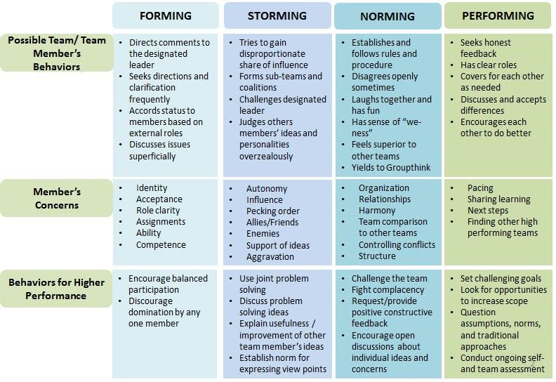

**3. General Problem Solving Steps**

1. **Defining the problem**: phrase problem as probing questions to encourage explorative thinking; make explicit goal statement
2. **Establish criteria for evaluating the solution**: identify characteristics of a satisfactory solution; distinguish requirements from desires
3. **Analysing the problem**: discover the root cause and extent of the problem
4. **Considering alternate solutions**: brainstorm to generate many ideas before judging any of them
5. **Evaluate alternate solutions**: use ranking-weighting matrix; check for issues/disagreement
6. **Deciding on a solution**: choose best answer to the problem from among all possible solutions
7. **Develop action plan**: make team assignments with milestones (don’t underestimate time)
8. **Implementing the action plan**: check for consistency with requirements identified in step 2
9. **Following up on the solution**: check up on the implementation and make necessary adjustments
10. **Evaluate outcomes and process**: review performance, process, and personal aspects of the solution

|  |  |
| --- | --- |
|  | **4. Decision Making Method Based on Time and Impact** |
| **5. Smart Decision Making is enabled by. . .** | |

* + Modelling an open mind and asking for candid opinions
  + Asking questions to encourage critical thinking and information disclosure such as:
    - What elements would you choose to change?
    - What changes would you make to solve …?
  + Aligning rewards to team successes to ensure that individuals share what they know
  + Ensuring that team members are aware of relevant roles and unique information required for team success
  + Charging some team members to assume a position that opposes the team’s preference
  + Creating an alternate team that attempts to find errors and weaknesses in the solution
  + Using successive rounds of blind voting interspersed with discussions

**6. Additional Readings**

Allen C 2013, *Blooms Critical Thinking Cues*, viewed 17 July 2020, < [http://pd.rubicon.com/wp-content/uploads/sites/8/2015/06/20-BloomQuestion-Cues-Chart.pdf](http://pd.rubicon.com/wp-content/uploads/sites/8/2015/06/20-Bloom-Question-Cues-Chart.pdf) >.

Hartnett, T n.d., Consensus decision making, viewed 21 July 2020, <<http://www.consensusdecisionmaking.org/>>.

Sunstein, C.R 2014, Making dumb groups smarter, Harvard Business Review, 92(12), pp. 90-98.

UMass|Dartmouth n.d., 7 steps to effective decision making, viewed 20 July 2020, <<https://www.umassd.edu/media/umassdartmouth/fycm/decision_making_process.pdf>>.

[The Himmelfarb Health Sciences Library](https://himmelfarb.gwu.edu/) Questions? [Ask us.](http://himmelfarb.gwu.edu/ask/)



All LibGuides by [Himmelfarb Health Sciences Library](https://himmelfarb.gwu.edu/) are licensed under a

[Creative Commons Attribution-NonCommercial-NoDerivs 3.0 Unported License](http://creativecommons.org/licenses/by-nc-nd/3.0/)

**Reflection**

**Problem-Solving and Decision Making** Decision making has much in common with problem solving. In problem solving you identify and evaluate solution paths; in decision making you make a similar discovery and evaluation of alternatives. In bullet point form, portray your group’s problem-solving or decision-making procedures.

**Response**

|  |
| --- |
|  |

## Key Professional Skill 3 – Power and Influence in Groups

1. **Overview** 
   * Power and influence are used to get others to act; power is based on positional authority while influence is based on relationships
   * Leaders use various sources of power to get others to act or change behavior
   * Some methods of influence are more effective than others
   * The amount of force used to influence, as well as the number of followers’ buy-in determines whether you’ll get resistance, compliance, or commitment
   * Individuals can employ numerous tactics to increase their influence

McIntosh & Luecke (2011)

1. **Difference between Power and Influence** 
   * Power is capacity to get others to act based on positional authority that is exercised over others; often leading to resentment
   * Influence is the ability to modify how a person develops, behaves, or thinks based on relationships and persuasion; often leading to respect

McIntosh & Luecke (2011)

1. **Various Sources of Power**

* + **Legitimate**: ability to request certain behaviours of others based on title, roles, or position (elected/ appointed)
  + **Reward**: ability to control the allocation of rewards valued by others and to remove negative sanctions
  + **Coercive**: ability to apply punishment (i.e., peer pressure) or take away items of value
  + **Expert**: ability to influence others based on the possession of valuable knowledge or skills
  + **Referent**: ability to influence others because the leader is admired and respected
  + **Information**: ability to influence based on access to and control over distribution of information
  + **Ecological**: ability to influence how tasks are organize or the ability to alter the team’s physical environment

Source: Harper et al.

1. Various Methods of Influence

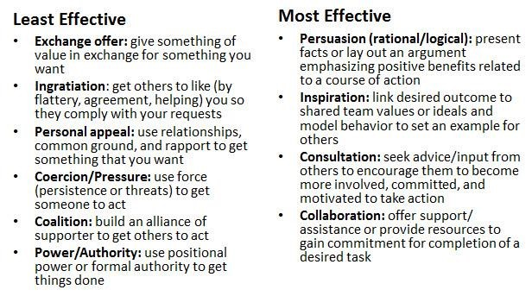

1. **Consequences of Influence Methods**

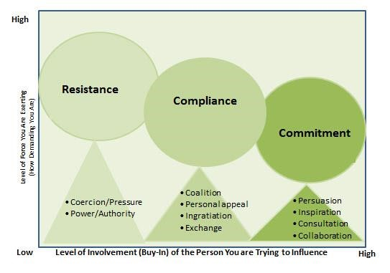

Source: Adapted from Fallbe & Yukl, G. (1992), p. 647.

1. **Tactics to Increase Influence** 
   * Offer assistance
   * Decrease workload, improve quality of work, help with goal attainment, or make others feel appreciated
   * Stand out as a source
   * Offer valuable information, resources, or expertise
   * Step in to resolve conflicts
   * Guide the team toward a common goal; solve problems to keep the team on track
   * Persuade team members think differently
   * Frame issues in different ways to lead to discovery of alternate solutions or new opportunities
   * Go above and beyond
   * Collaborate, contribute to individuals, and support the team
   * Show interest in others
   * Indicate your understanding of other people’s needs and interest

Additional Reading

* + Falbe, C.M., & Yukl, G 1992, Consequences for managers of using single influence tactics and combinations of tactics, *Academy of Management Journal, 35*(3), pp. 638-652.
  + Kokemuller, N n.d., Five Levels of Influence in Leadership, viewed 19 July 2020, < [http://yourbusiness.azcentral.com/five-levels-influence-leadership10466.html](http://yourbusiness.azcentral.com/five-levels-influence-leadership-10466.html) >.
  + McIntosh, P., & Luecke, R 2011, Increase your influence at work, American Management Association: New York.
  + Rykrsmith, E 2011, Becoming a better influencer: 4 most effective influence tactics (Part 1), Fast Track, viewed 17 July 2020, < <https://www.quickbase.com/blog/becoming-a-better-influencer-4-most-effective-influence-tactics-part-i>>.
  + Rykrsmith, E 2011, Becoming a better influencer (Part 2): The least effective influence tactics, The Fast Track, viewed 17 July 2020, < <https://www.quickbase.com/blog/becoming-a-better-influencer-part-ii-the-least-effective-influence-tactics>>.
  + Yukl, G. & Tracey, J.B 1992, Consequences of influence tactics used with subordinates, peers, and the boss [Electronic version], viewed 18 July 2020 < <https://scholarship.sha.cornell.edu/articles/882/> >.



**Reflection**

**Power and Influence in Groups** reflects two concepts, that of power and influence. Power seeks coercion whereas influence seeks to create a conversation where all members feel valued and are heard.

### Power and influence Reflection

1. What do you think is unique about your group environment in terms of power and influence?
2. How did your group seek to create an environment of influence?
3. How do you think this could have been done better?

### Response

|  |
| --- |
| 1. |
| 2. |
| 3. |

## Key Professional Skill 4 – Cooperation, Consensus Decision-making and Effective Communication in Groups

1. **Overview** 
   * Promote clear communications with succinct, direct, and unique statements
   * Encourage effective communications by promoting team cohesiveness and ensuring collective understanding
   * Improve communications by using cooperative rather than competitive strategies
   * Cooperation is displayed by performing assigned roles, working together, and directing efforts toward a common goal
   * Deal with rudeness by investigating the behavior; confronting the behavior; deciding whether or not to respond; offering support
2. **Promote Clear Communications By. . .** 
   * Stating or restating purpose/goals to ensure focus on priorities
   * Discussing one topic at a time
   * Leading with the main point
   * Making the point clearly and concisely
   * Keeping the message simple
   * Using short direct statements
   * Avoiding long-winded indirect arguments
   * Adding unique concepts (not repeating what others have said)
   * Stating decisions clearly to ensure understanding
   * Providing regular feedback to maintain focus on goals

**Encourage Effective Communications By. . .**

* + Promoting team cohesiveness
  + Recognize both personal and team goals
  + Commit to transparency (no hidden agendas)
  + Accept different opinions and perspectives
  + Ensuring collective understanding
  + Assess team members’ familiarity with information
  + Share all pertinent information (both positive and negative)
  + Confirm the meaning of common words across different professions

1. **Improve Communications By. . .**

* Focusing on your perceptions instead of judging or accusing team members
* Being problem oriented rather than controlling
* Clarifying your needs and including team members in finding a solution instead of having ulterior motives
* Conveying empathy for team members rather than indifference
* Empowering team members and valuing their contributions instead of making them feel inferior or inadequate
* Acknowledging other points of view and possibilities instead of being narrow minded and unwilling to listen

1. **Foster Team Cooperation By. . .** 
   * Putting team needs first
   * Respecting and trust each other
   * Seeking out and share information
   * Incorporating and act on team members’ suggestions
   * Accepting and perform unpleasant tasks positively
   * Following through on action items
   * Completing individual tasks on time
   * Helping team members complete tasks, if necessary
2. **Deal with Personal Attacks, Disrespect, and Antisocial Behavior By. . .** 
   * Investigating the behavior and addressing the underlying issues
   * Judge the person’s rudeness fairly (Was it a blind spot or malicious?)
   * Investigate the reason behind the rudeness by simply asking “Why are you treating me this way?”
   * Attempt to understand the person’s perspective
   * Address the root cause concealed behind the rudeness
   * Confronting the behavior
   * Call the person out on their inappropriate behavior in a polite, firm manner
   * Summarize the behavior so the person can realize how inappropriate it was
   * Avoid over analysis of the situation if confrontation doesn’t result in change
   * Deciding whether or not to respond
   * Take the power out of the rudeness by not taking it personally (even if it was meant that way)
   * Ignore the behavior, keep your dignity intact, and refuse to escalate the situation
   * Remove yourself from the situation or limit contact
   * Realize that you can’t change other people
   * Refuse to engage habitual offenders; allow them to figure out their own issues
   * Supporting the individual when possible
   * Offer immediate help to resolve a frustrating situation
   * Increase your value to the person by becoming a problem solver
   * Resolve to remain professional and pleasant while offering assistance
3. **Additional Reading** 
   * Anonymous n.d., How to deal with rude people – co-workers, associates, customers, managers, etc., viewed 21 July 2020, <<http://personalexcellence.co/blog/rude-people/>>.
   * Gibb, J. R 1982, Defensive communication, *The Journal of Nursing Administration*, 12(4), p. 14.
   * Johnson, D. W., & Johnson, F. P 2013, Joining together: Group theory and group skills, Boston: Pearson.
   * Levi, D 2011, Group dynamics for teams, Los Angeles, Calif. u.a.: SAGE, pp. 91-107.
   * Lizard, S (n.d., 10 smart ways to deal with rude people, viewed 20 July 2020, < [http://www.lifehack.org/articles/communication/10-smart-ways-deal-withrude-people.html](http://www.lifehack.org/articles/communication/10-smart-ways-deal-with-rude-people.html) >.
   * Riskin, A., Erez, A., Foulk, T.A., Kugelman, A., Gover, A., Shoris, I., Raskin, K.S., Bamberger, P.A 2015, The impact of rudeness on medical team performance: A randomized trial, *Pediatrics*, 136(3), pp. 487-495.
   * Lesmeister, M.K 2009, Working with others: Developing trust and cooperation, viewed 19 July 2020, < <http://ufdcimages.uflib.ufl.edu/IR/00/00/33/47/00001/FY74800.pdf>>.



**Reflection**

**Cooperation, Consensus Decision-making and Effective Communication in Groups**

Group decision-making is subject to contextual and social influences that impact heavily on the group decision-making process:

### Cooperation and Consensus Reflection

1. How would you describe the decision-making process in your group?
2. What do you think impacted on this approach?
3. Can you define the advantages or disadvantages of your approach?

### Response

|  |
| --- |
| 1. |
| 2. |
| 3. |

## Key Professional Skill 5 – How to Run a More Effective Meeting

By [Adam Bryant](https://www.twitter.com/nytcorneroffice)

We’ve all been stuck in a bad meeting. You arrive on time only to have the meeting start 10 minutes late. The agenda? Unclear. The person in charge? Also. Some people start to offer ideas, others shoot them down. Nothing is really decided, and the meeting wraps up, as you silently lament the lost hour. There is a better way. Over the course of speaking to more than 500 chief executives for my weekly Corner Office column, I have learned the rules to running an effective meeting. These tips and strategies can work for anyone, regardless of title.

**The Three Rules of Running a Meeting**

**1. Set the Agenda**

“Give me an agenda or else I’m not going to sit there, because if I don’t know why we’re in the meeting, then there’s no reason for a meeting.” —[Annette Catino, chief executive of the QualCare Alliance Network](http://www.nytimes.com/2012/04/15/business/annette-catino-of-qualcare-on-building-business-ties.html).

It may seem like an obvious requirement, but a lot of meetings start with no clear sense of purpose. The meeting’s agenda can be summarized on a handout, written on a whiteboard or discussed explicitly at the outset, but everyone should know why they’ve gathered and what they’re supposed to be accomplishing. **The agenda provides a compass for the conversation,** so the meeting can get back on track if the discussion wanders off course.

If leaders make sure there is an agenda before a meeting starts, everyone will fall in line quickly.

“If I don’t have an agenda in front of me, I walk out,” said Annette Catino, chief executive of the QualCare Alliance Network. “Give me an agenda or else I’m not going to sit there, because if I don’t know why we’re in the meeting, and you don’t know why we’re there, then there’s no reason for a meeting. It’s very important to me to focus people and to keep them focused, and not just get in the room and talk about who won the Knicks game last night.”

**2. Start on Time. End on Time.**

Nothing can drain the energy from a room quite like waiting for the person in charge to show up. Why do so many in positions of power fall into the bad habit of being late for meetings? Is it just that they’re so busy? Or is there a small thrill in keeping everyone waiting for them, a reminder that their time is somehow more valuable than everyone else’s?

Time is money, of course, and all that sitting around and trying to guess when the boss may arrive is a waste of a precious resource. **When establishing the informal rules of an organization, employees take their cues from the person in the corner office.** If that person wants meetings to start on time, meetings will start on time.

Terry Lundgren, the chairman of Macy’s, has never hesitated to enforce a strict policy of on-time meetings. “If the meeting is at 8, you’re not here at 8:01, you’re here at 8, because the meeting’s going to start at 8,” he said. “Busy people that can’t get off the last phone call to get there, [need to] discipline themselves to be there on time.”

Just as important as starting on time is ending on time. A definitive end time will help ensure that you accomplish what’s on your agenda and get people back to their work promptly. “I like to have an agenda that we think through,” Mr. Lundgren added, “and we say, ‘This meeting’s going to go for two hours,’ and we force ourselves to carve through the agenda.’”

**3. End with an Action Plan**

**Leave the last few minutes of every meeting to discuss the next steps.** This discussion should include deciding who is responsible for what, and what the deadlines are. Otherwise, all the time you spent on the meeting will be for naught.

Shellye Archambeau, chief executive of MetricStream, a firm that helps companies meet compliance standards, likes to end her meetings by asking, “Who’s got the ball?”

“When you’re in sports, and the ball is thrown to you, then you’ve got the ball, and you’re now in control of what happens next,” she said. “You own it. It becomes a very visible concept for making sure that there’s actually ownership to make sure things get done.”

Mark Toro, managing partner of North American Properties – Atlanta, a real estate operating company, uses a phrase to end meetings that has become a common acronym in office e-mails: **W.W.D.W.B.W., which stands for “Who will do what by when?”**

“If somebody says during a meeting, ‘We’ve got to get this lease signed,’ everybody knows what the follow-up question is going to be. I type the acronym so often in emails — “W.W.D.W.B.W.” — that my phone just auto-fills it. So we’ve trained ourselves and each other, but we’re also trying to do it with people we work with. We developed a system where before we hang up the phone with somebody, we’ll say, ‘When do you think I can have that?’ We track people who deliver and those who don’t.”

**How to Run A Great Virtual Meeting**

* [Keith Ferrazzi](https://hbr.org/search?term=keith%20ferrazzi) Harvard Business Review
* <https://hbr.org/2015/03/how-to-run-a-great-virtual-meeting>

**MARCH 27, 2015**

Virtual meetings don’t have to be seen as a waste of time. In fact, they can be more valuable than traditional face-to-face meetings. Beyond the fact that they’re inexpensive ways to get people together – think: no travel costs and readily available technology – they’re also great opportunities to build engagement, trust and candour among teams.

Several years ago, my company’s Research Institute embarked on an exploration of the [“New People Rules in a Virtual World”](http://keithferrazzi.com/article/keith-techonomy-detroit-new-people-rules-virtual-world) to explore how technology is shaping our relationships and how we collaborate. This multiyear journey also evolved my thinking on the subject, helping me recognize that virtual is not the enemy of the physical if key rules and processes are maintained and respected.

Going back through that research now, I’ve put together a comprehensive list of some simple do’s and don’ts to help you get the most out of your next virtual meeting.

**Before the meeting:**

***Turn the video on.***Since everyone on the call is separated by distance, the best thing you can do to make everyone at least feel like they’re in the same room is to use video. There are many options to choose from, such as WebEx and Skype. Video makes people feel more engaged because it allows team members to see each other’s emotions and reactions, which immediately *humanizes* the room. No longer are they just voices on a phone line; they’re the faces of your co-workers together, interacting. Without video, you’ll never know if the dead silence in a virtual meeting is happening because somebody is not paying attention, because he’s rolling his eyes in exasperation or nodding his head in agreement. Facial expressions matter.

***Cut out report-outs.***Too many meetings, virtual and otherwise, are reminiscent of a bunch of fifth graders reading to each other around the table – and that’s a waste of the valuable time and opportunity of having people in a room together. The solution is to send out a simple half-page in advance to report on key agenda items – and then only spend time on it in the meeting if people need to ask questions or want to comment.

This type of pre-work prepares participants to take full advantage of the meeting by thinking ahead about the content, formulating ideas or getting to know others in the group, which can help keep team members engaged, says business consultant Nancy M. Settle-Murphy in her book [*Leading Effective Virtual Teams*](http://www.amazon.com/Leading-Effective-Virtual-Teams-Exceptional/dp/1466557869). But one thing is critical: It has to be assumed that everyone has read the pre-read. Not doing so becomes an *ethical* violation against the team. I use the word “ethical” because it’s stealing time from the team — and that’s a disrespectful habit. The leader needs to set the tone aggressively that the pre-read should be done in advance.

***Come prepared with the team’s opinions****.*Not only do you need to do your pre-reads, but once you see the agenda, make sure you discuss with your team what is going to be covered – that is, do your own due-diligence. What happens all too often is that people get on virtual calls with a point of view, but because they haven’t done any real homework before the call, they end up reversing their opinions once the call has ended and they’ve learned new information that they could have easily obtained in advance. If there’s a topic that seems to have interdependencies with people who work in our location, get their input ahead of time so you’re best representing those constituents in the meeting.

**During the meeting:**

***Connect people****.*People perform better when they are comfortable with each other, which affords a greater degree of candour and mutual interest. Your job as a leader, particularly when people may not know each other, is to make them feel connected so you can have a productive meeting. How? Do a personal-professional check-in at the beginning of each meeting. Have team members take one minute and go around to talk about what’s going on in their lives personally and professionally. Go first to model the approach for what doing it “right” looks like, in terms of tone and candour. Remind everyone to respect each other by not interrupting and to only say what they’re comfortable sharing with the group.

***Encourage collaborative problem solving****.*A collaborative problem solving session replaces the standard “report-outs” that can weigh meetings down. It’s when the leader raises a topic for group discussion and the team works together – and [sees each other as sources of advice](https://hbr.org/2015/02/use-your-staff-meeting-for-peer-to-peer-coaching) – to unearth information and viewpoints, and to generate fresh ideas in response to business challenges.

***Give each person time on the agenda.***Along with collaborative problem solving, giving each person time on the agenda fosters greater collaboration and helps get input from all the team members. Here’s how it works: In advance of the session, have team members write up an issue they’ve been struggling with and bring it to the table, one at a time. Each team member then gets five minutes on the agenda to discuss his or her issue. The group then goes around the meeting so everyone gets a chance to either ask a question about it or pass. After the team member answers everyone’s questions, people then get an opportunity to offer advice in the “I might suggest” format, or pass. Then, you move on to the next issue. It’s a very effective use of a collaboration technique that could easily be managed in a virtual environment.

***Kill mute.***In a co-located meeting, there are social norms: You don’t get up and walk around the room, not paying attention. Virtual meetings are no different: You don’t go on mute and leave the room to get something. In a physical meeting, you would never make a phone call and “check out” from the meeting. So in a virtual meeting, you shouldn’t press mute and respond to your emails, killing any potential for lively discussion, shared laughter and creativity.

As leaders, we need to establish a standard: Just because you’re in a virtual meeting and it’s possible to be disrespectful, it has to be understood that it’s unacceptable. We’re talking about civility and respect for people, so if you wouldn’t do it in person, don’t do it virtually.

***Ban multitasking****.*Multitasking was once thought of as a way to get many things done at once, but it’s now understood as a way to do many things poorly. [As science shows us](http://www.ncbi.nlm.nih.gov/pmc/articles/PMC2527865/), despite the brain’s remarkable complexity and power, there’s a bottleneck in information processing when it tries to perform two distinct tasks at once. Not only is this bad for the brain; it’s bad for the team. Managers should set a firm policy that multitasking is unacceptable, as it’s important for everyone to be mentally present.

Here are three ways to make sure the ban on multitasking is followed:

* Use video: It can essentially eliminate multitasking, because [your colleagues can see you](https://hbr.org/2014/12/getting-virtual-teams-right).
* Have the meeting leader call on people to share their thoughts. Since no one likes to be caught off-guard, they’ll be more apt to pay attention.
* Give people different tasks in the meeting, rotated regularly. To keep people engaged, have a different team member keep the minutes of the meeting; track action items, owners and deadlines; and even come up with a fun question to ask everyone at the conclusion of the meeting.

Nick Morgan, president of consulting company Public Words Inc., [recommends](https://hbr.org/2011/03/how-to-conduct-a-virtual-meeti) constant touchpoints: “In a virtual meeting, you need to stop regularly to take everyone’s temperature. And I do mean everyone. Go right around the list, asking each locale or person for input.”

***Assign a Yoda****.*Candour is difficult even for co-located teams, but it’s the number one gauge of team productivity. To keep people engaged during virtual meetings, appoint a “Yoda.” Like the wise Jedi master in *Star Wars*, the Yoda keeps team members in line and makes sure everyone stays active and on topic. The Yoda [keeps honesty from boiling over into disrespect](https://hbr.org/2014/01/how-virtual-teams-can-create-human-connections-despite-distance) by being courageous and calling out any inappropriate behaviors. At critical points during the meeting, the leader should turn to the Yoda and ask, “So, what’s going on here that nobody’s talking about?” This allows the Yoda to express the candour of the group and encourage risk-taking.

**After the meeting:**

***Formalize the water cooler.***Have you ever been in a meeting, and just when it ends, everybody walks out and vents their frustrations next to the water cooler? Make the water cooler conversation the formal ending of the virtual meeting, instead. Five to 10 minutes before the meeting ends, do what everybody would’ve done after the physical meeting – but do it *in* the meeting and make sure it’s transparent and conscious, processing people’s real feelings.

How? Have everyone go around and say what they would’ve done differently in the meeting. This is like the final “Yoda” moment – it’s the “speak now or forever hold your peace” moment. This is the time when you say what you disagreed with, what you’re challenged with, what you’re concerned about, what you didn’t like, etc. All of the water-cooler-type conversation happens right now, or it never happens again. And if does happen later, you’re violating the ethics of the team.

Most importantly in virtual meetings, civility and respect must be the norm. There have to be inalienable, ethical rules that you follow before, during and after a virtual meeting for it to be truly successful. And that means adhering to two fundamental principles: Be respectful of others’ time and be present. Failing to do so steals precious hours from the team that can never be recovered. Co-located teams have enough problems building candour and trust; teams separated by distance really need to have great meetings to build these connections.

**Reflection**

**Running effective team meetings**

### Check list of an effective team meeting.

Check off all items you achieved or will achieve in your team meetings:

Cleary defined objective is set

Meeting time is set

Meeting location is set

Agenda is prepared

Meeting starts on time

Agenda is followed

One topic discussed at a time

Time schedule is followed

Everyone has a chance to express an opinion

Progress was made towards the objective

Important decisions and discussions documented

Meeting ends on time

Everyone knows the next step

Team members receive a follow-up mail regarding decisions and tasks within 24 hours.

## Key Professional Skill 6 – Sort your tasks by urgency and importance.

**"What is often urgent is not important and what is often important is not urgent"**

* **Important” and “Urgent” tasks.** These receive the highest priority level and should be your primary focus to complete as soon as possible (most often on the same day).
* **“Important”, but “Not Urgent” tasks.** These are the long-term goals and tasks that are important but don’t have a firm deadline yet.  You should schedule them in a timely manner, doing the most urgent ones right after you’ve finished everything from the “Do” quadrant.
* **“Not Important”, but “Urgent” tasks.** These tasks are the ones you can delegate to other professionals or appoint to complete yourself if you must, but only after your first and second quadrant tasks are completed.
* **“Not Important” and “Not Urgent” tasks.** The tasks are placed in the “Delete” quadrant because you should eliminate doing them. This may vary due to the perception of urgency and importance, but mainly these tasks don’t even need to be done and would be considered a complete waste of time by most people.

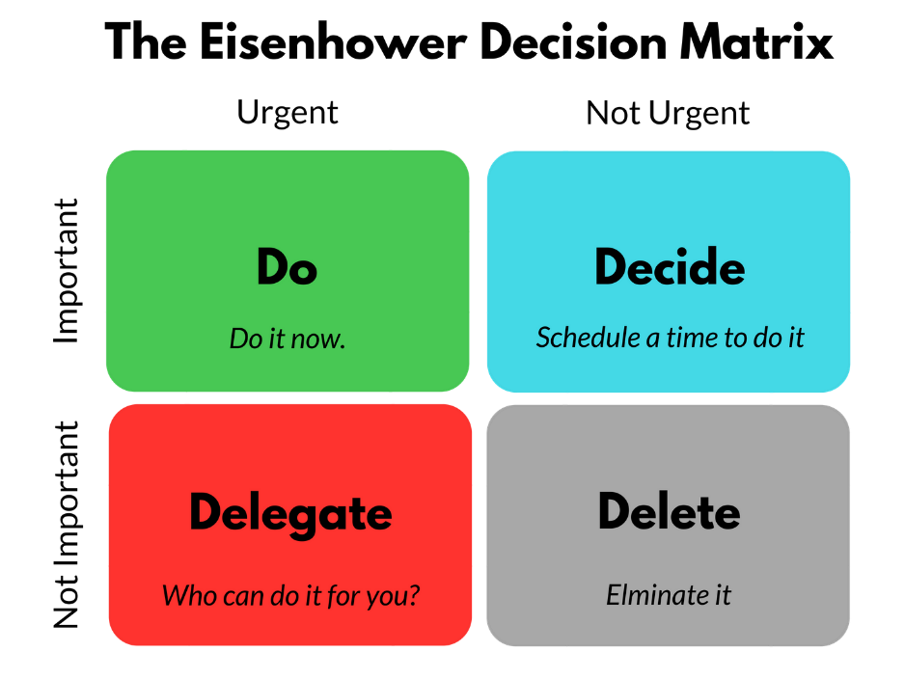

**Reflection**

**Sort your tasks by urgency and importance**

### Reflection on prioritising tasks

1. Identify two variables/issues your group considered when prioritising tasks?

2. Give one example of an urgent/not urgent, important/not important task you identified in the course of your group work.

### Response

|  |
| --- |
| 1. |
| 2. |

**Key Professional Skill 7 – Managing Team Free-loaders**

**Social Loafing or free riding**

What we refer to as the process of social loafing – the situation where one or more group members do not put all they can into the task – where individual members can hide a lack of contribution under the umbrella of diffused responsibility – where responsibility for the task is spread over the whole group.

This is known as the Ringelmann effect in honour of the person who first documented the fact.

Which states that:

**People become less productive when they work with others**

**That this loss of efficiency increases with group size**

Ringelmann identified two types of process loss:

Firstly, **coordination losses** – as groups increase in size productivity efficiency is reduced due to coordination problems. Just think of 10 people carrying a log – there will be those putting maximum effort in and those who are barely contributing.

Secondly the issue of **social loafing or free riding**. Which tends to complicate coordination problems

**How do you try to maximize group output by reducing the position where people tend to coast along at the others expense?**

Several options:

**Increase identifiability** – to make each individuals contribution to the group task known to others. Avoid the situation where everyone’s efforts are pooled with no distinct role definition amongst group members.

**Minimize free**-riding by making the group as small as possible. As groups grow in size so you are going to find more free riding.

**Set clear specific goals** – groups that are working towards clear goals tend to loaf a bit less. If those group goals can be associated with specific individual goals so the opportunity for free riding will be reduced.

**You can increase engagement** by building in task interdependence. Free riding is the worst where individuals can complete their tasks without a high level of collaboration. If you can link group member’s performance together so **person A** cannot complete their task until **person B** has completed their task, then this interdependence of tasks will serve to minimize free riding.

**There is research** which shows that if individuals strongly identify with their groups so free riding can be minimized. The object is to get individuals working for the group not just themselves.

So,

* Increase identifiability
* Make the group as small as possible
* Set clear, specific goals
* Build in task interdependence
* Increase identification with group

[The problem of free-riding in group projects Looking beyond social loafing as reason for non-contribution-2.pdf](https://swinburne.instructure.com/courses/19805/files/5951112/download?wrap=1)

**Reflection**

### Managing Team Free-loaders

### Reflection (answer which is applicable)

1. Did your group encounter this issue? If so what steps did you take to resolve the matter?

2. If your team did not encounter this issue, why do you think this was the case?

### Response

|  |
| --- |
| 1. |
| 2. |